week wise report

Week 3 and 4:
FreelanceHub – Weekly Work Summary
- Developed the basic structure of FreelanceHub, a website that connects freelancers with clients.
- Created the homepage using HTML5.
- Added freelancer profiles and skill sets to showcase their expertise.
- Included search options to help clients find suitable freelancers.
- Created a freelancer registration form and a project requirement form for clients.
- Implemented CSS styling using Flexbox, Grid, and CSS variables.
- Worked on responsive design to improve the website’s appearance and usability across different devices.
- Focused on frontend development, with backend functionality and data storage planned for future development.

Fig 1 Dashboard
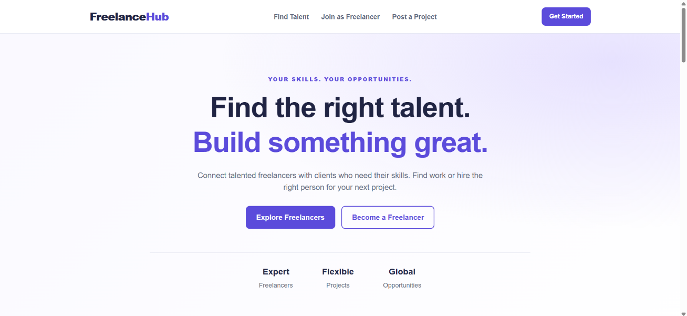
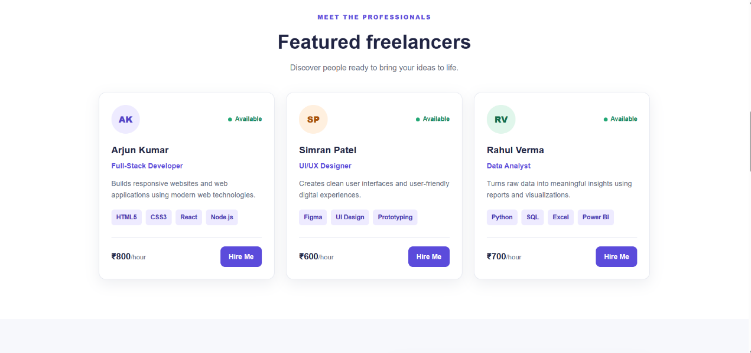
Fig 2 Implementation of Div

Week 5 and 6:
Implemented javascript for logic What the JavaScript does:
- Shows the freelancer cards: It takes raw data and turns it into readable cards on the screen.
- Filters as you type: When you search a skill, pick a category, or set a budget, it instantly shows only the matching people without reloading the page.
- Does quick math: It adds up rates and shows the average hourly price of the visible freelancers.
- Adds new people: When you fill out the sign-up form, it immediately adds the new profile to the list right on your screen

Week 7 and 8:
First Json :
- freelancers.json is your project’s small database. It only stores the data: names, roles, rates and skills. It doesn’t do anything by itself. script.js does the work:
fetch('./freelancers.json') asks for the file.
response.json() converts the text into real JavaScript objects.
The script loops over them and builds a card on the page for each freelancer.

Week 8 requires fetch, and fetch needs something to fetch. Without the JSON file, you’d have nothing to demonstrate it on.
don’t have a server, so freelancers.json plays that role: fetch('./freelancers.json')

upgraded my static FreelanceHub website into a dynamic one using asynchronous JavaScript and browser APIs.
Files
- freelancers.json: new file with the freelancer data. It simulates an API.
- script.js: new file with all the JavaScript logic.
- index.html: the hard-coded cards were removed, and I added ids, status messages and the script link.
- style.css: new styles for the toolbar, favourite button and messages.
Week 7: Asynchronous JavaScript
- Callbacks: simulateServerCallback takes onSuccess and onError functions and calls one after a 700 ms delay.
- Promises: simulateServer wraps that callback in a Promise. The project form uses .then().catch().finally().
- async/await: loadFreelancers and handleJoinSubmit use await with try/catch/finally for error handling.
Week 8: Browser APIs
- fetch: loads freelancers.json, checks response.ok, and shows loading and error states.
- DOM manipulation: the freelancer cards are created in JavaScript with createElement and textContent, instead of being written in HTML.
- Events: live search (with debounce), filters, form submit with preventDefault, and one delegated click listener for the ♥ and Hire Me buttons.
- localStorage: saves new profiles, submitted projects, favourites and search filters. The data stays after a page refresh.

Week 9 and 10 :

We changed your plain HTML, CSS and JavaScript website into a React project. The design and the freelancer data stay the same.
What’s new:
- Custom errors: we made our own error types (like network, storage and form errors), and the code catches them with try/catch and shows a clear message to the user.
- Forms: all inputs are now controlled by React, so React always knows what is typed in each field. We also check the values, for example the email, the rate and the deadline.
- Events: clicks, typing and form submits now use React’s onClick, onChange and onSubmit instead of addEventListener.
- Components: the page is split into small pieces (Header, Hero, search form, freelancer cards, join form, project form, Footer) that are put together in App.jsx.
- Lifting state up: shared data like filters, favourites and the “Hire Me” choice lives in App.jsx and is passed down to the pieces that need it. That’s how clicking “Hire Me” fills the project form.
- Hooks: useState stores the data, and useEffect loads the JSON file and saves things to localStorage.
- NPM and GitHub: the project has a package.json with run commands, a .gitignore, and a README that explains the Git steps (create repo, branch, pull request, merge).
How to run it: use npm install, then npm run dev.
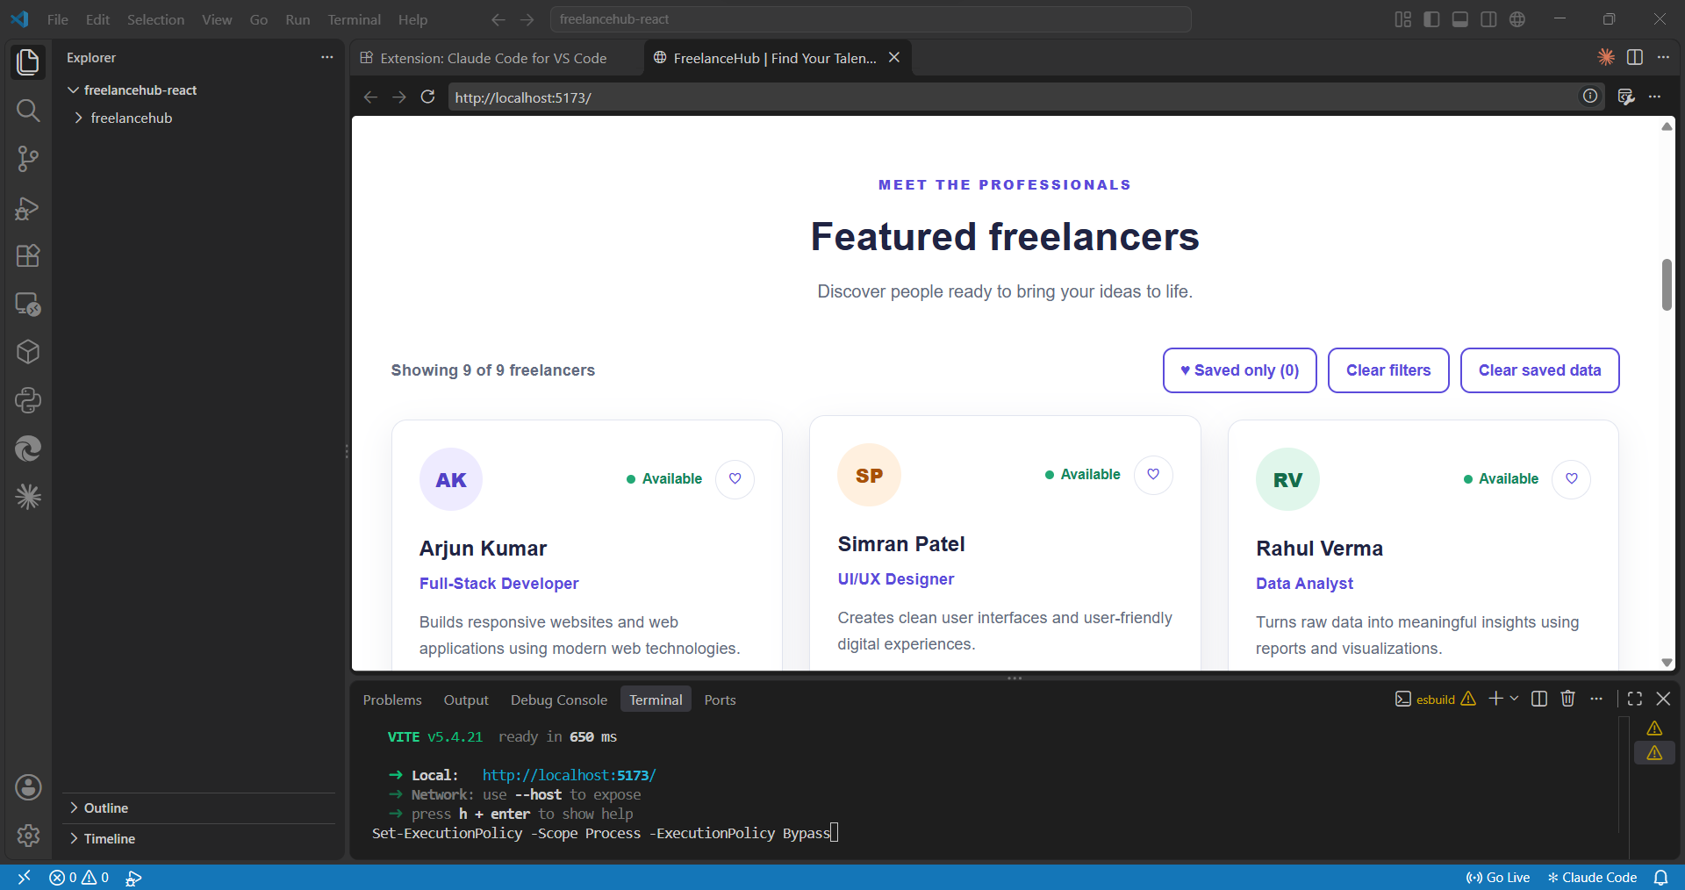

Week 11 and 12:
- . Hooks (React tools)
- Shared box (useContext): all the important data (freelancers, favourites, filters) is kept in one place. Any part of the website can use it directly.
- Remember results (useMemo): the list and the numbers at the top (total freelancers, available, average rate) are only calculated again when the data changes. This makes the site faster.
- Remember functions (useCallback): some functions are kept as they are, so the freelancer cards don’t refresh again and again.
- Direct access (useRef): if you make a mistake in a form, the cursor jumps to the wrong field. The Search button also scrolls down to the results.
- Our own hooks: we made small reusable tools for saving data in the browser, waiting while you type, loading freelancers, and setting the page title.
- 2. Pages (React Router)
- The website is no longer one long page. It now has separate pages:
- Home
- Find Talent (with “All” and “Saved” tabs)
- Freelancer profile (one page per freelancer)
- Join as Freelancer
- Post a Project
- 404 page if the link is wrong
- Clicking Hire Me opens the project form with that freelancer’s name already filled in.
- After you create a profile, you are taken to your new profile page.

